Final Project Design Phase
Computer Science - Week 11
Oct 3, 2026 - Version 0.0.4

For complete instructions and project ideas, refer to the assignment in Canvas. Specifically, review the final project requirements before you continue below. If you have not reviewed the project requirements in Canvas (you might have to go to the modules view and check the current or past week's content), you will not be able to properly complete the parts below. In addition, it may be helpful to review the information on this Drafter documentation page.

0) Project Planning and Preparation
Successful programmers spend time planning before they begin coding. After reviewing the project requirements, answer the following questions to help guide your design and development process.
- What concepts from class or previous assignments might help you complete this project? Which programming concepts (loops, conditionals, lists, classes, etc.) do you expect to use? What programming skills do you want to improve while completing this project?
Concepts that might help me complete this project are dataclasses to store each entry (pool, ph, chlorine, who took the reading, time of reading). Along with conditionals to check if the ph or chlorine is in the accepted range or not. Programming skills I wish to improve while completing this project are working with large amounts of code, it's something I struggled with in the past and something I am looking forward to tackling again.

- Which parts of the project do you expect to be the easiest for you? The hardest? Why?
I expect the work with dataclasses to be challenge for me because I am not the best at unit testing dataclasses, its been something I’ve struggled with and combined with a larger amount of code I expect it to be a little more challenging. The easiest I think will be if statements for the conditionals just because we’ve done so much work with them in class.

- Even though you have not yet designed the final project, estimate which tasks will likely require the most time and effort? Which features or components should be implemented first?
I think the time will fall into almost a reverse bell curve with the most being the initial set up of data being entered into dataclasses, then not much time being needed in setting up the data being stored/called and checked, then again more time devoted to using drafter to get the website up and running. I should implement these components in this order as an early estimate.

- What distractions might interfere with your work and how will you minimize them? What resources will you need available while working? What questions, if any, do you still have about the assignment requirements?
Distractions are both in a macro sense my phone/people around me so when I go to my dedicated time to work I’ll make sure to have my phone away and be in a quiet sense. In a micro sense for work when coding I tend to fall into all or nothing thinking/wanting things to be perfect which can be a time suck and counter productive so I will try to be cautious of that. I do not have any more questions about assignment requirements.

1) Site Diagram
Create a mock-up of your planned website. We suggest you make the mockup on paper, although you can also use software like PowerPoint or Slides to make a mockup. There is other design software that could also be used, but we strongly encourage you to keep it simple. Do not spend more than 15-30 minutes detailing the mock-up. Your goal should be to make a very quick and dirty diagram, to show that you have some kind of idea.

We recommend drawing each page as a rectangle, and laying out the text, buttons, and other components inside. Then, use arrows to indicate links between pages. Label each page the way you will name each function, and then put labels on the arrows to indicate what the button links. Also write down any parameters that should come into the pages.

In addition to the pages and routes, write down what fields your `State` will have, both their names and types. Think clearly about what data will need to be persistent across the entire website.

Add photo(s) or screenshot(s) of your website mock-up and labeled diagram on the next page.
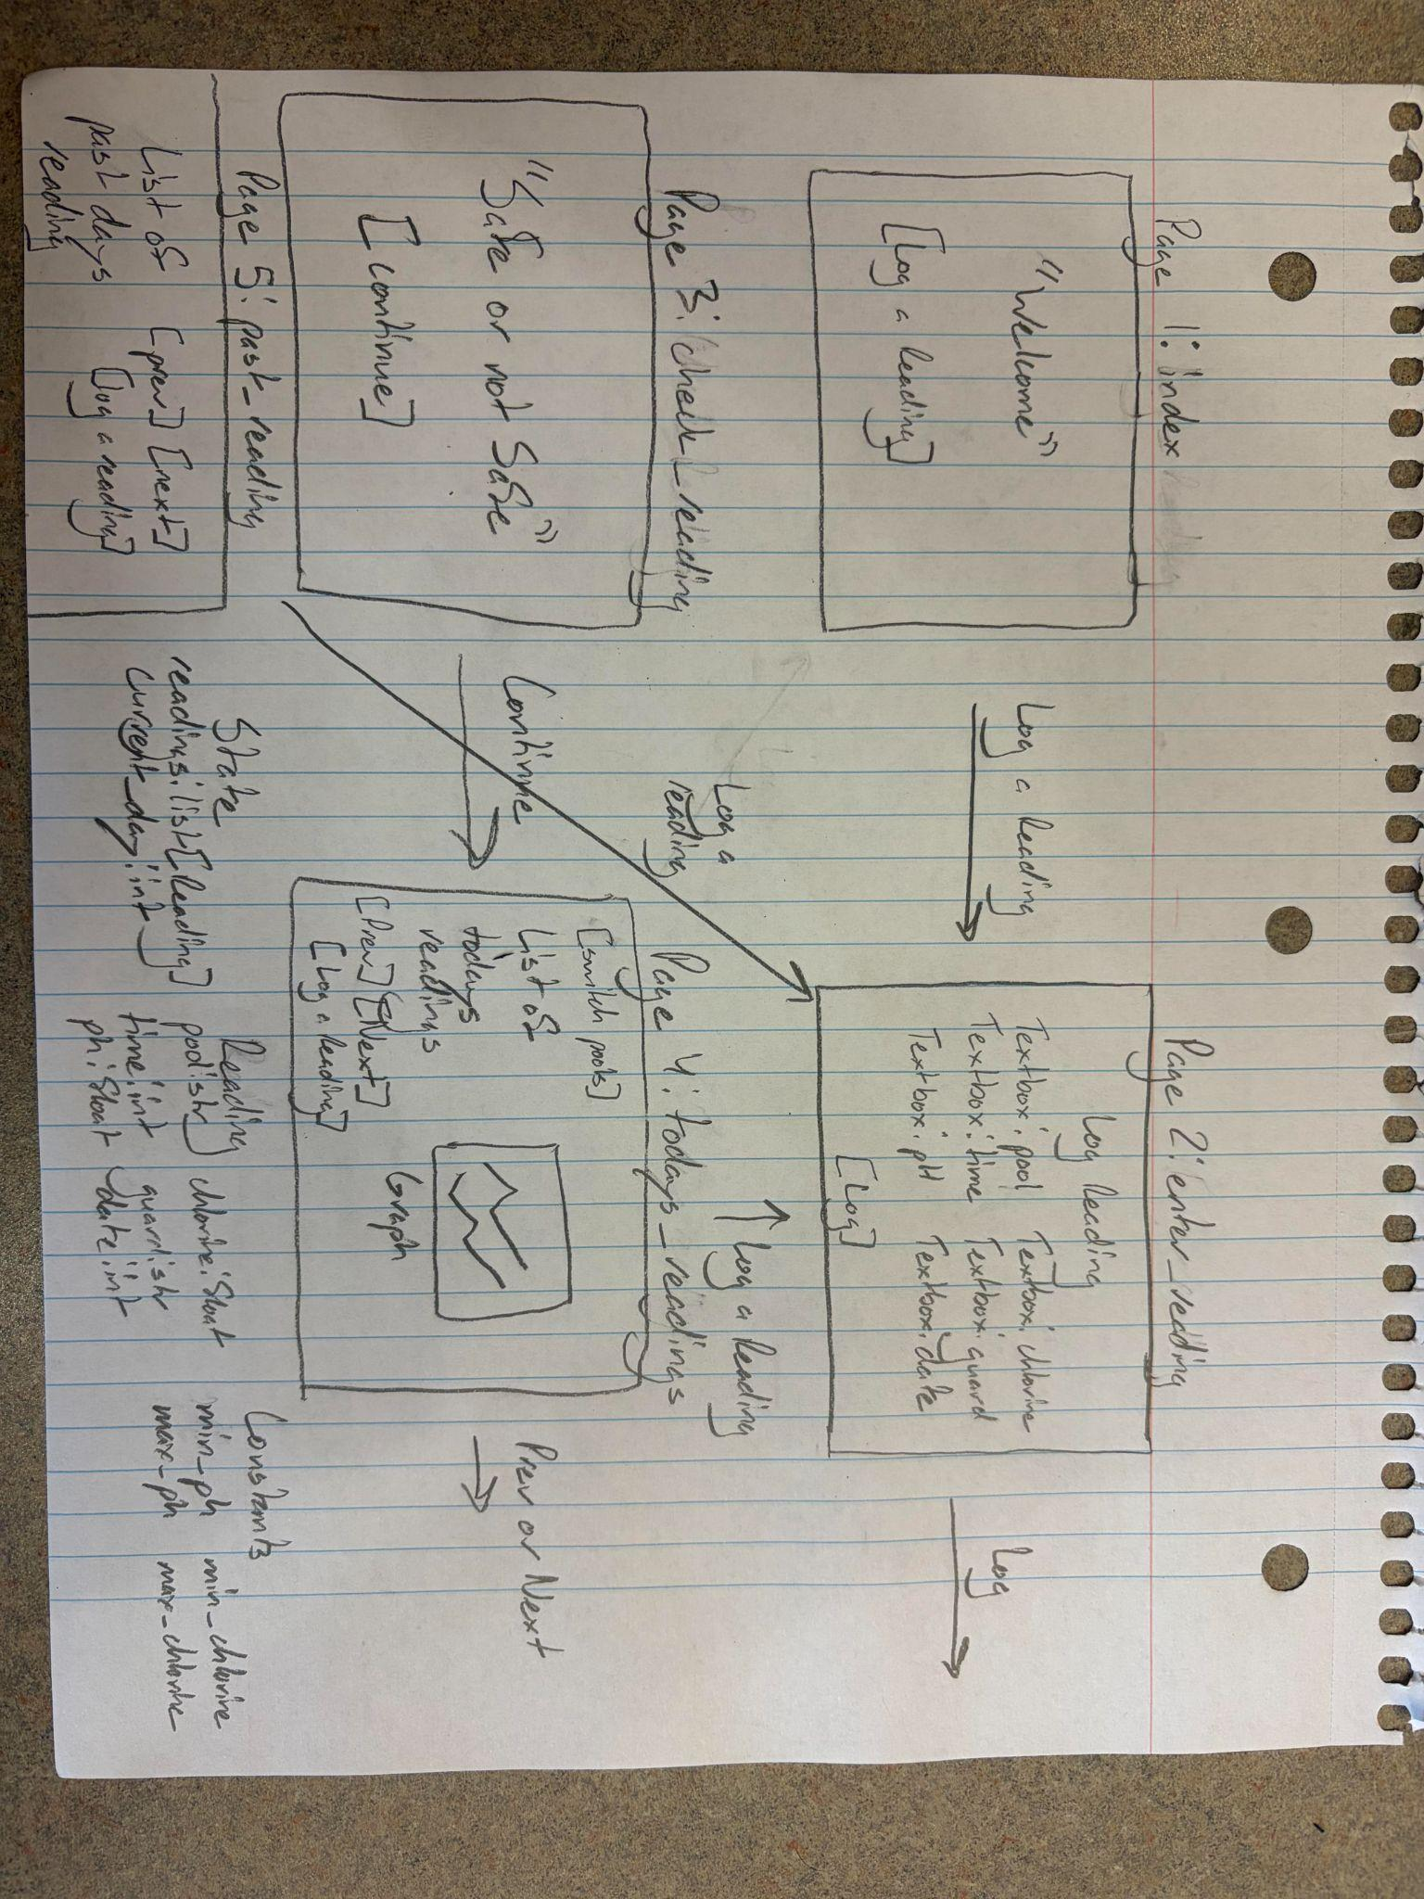

2) Implementing Requirements
This table should serve as a draft for how you will implement the requirements into your final project. You may change your ideas later on, but your final site must fulfill all the requirements.

Requirement | Implementation
Purpose/Functionality  A 1-2 sentence description of the purpose or functionality of your site | The purpose of this website will be a way for lifeguards to store and check chemical tests (pH and Chlorine).
State Dataclass Attributes  Minimum of 4 attributes, one of which must be a list/dict of instances of your second dataclass.  Briefly describe each attribute, its type, and how it will be meaningfully modified throughout the site. | State  readings:list[Reading]  *new readings will be added to list in check_reading  current_day:int  *when going between pages with prev and next it will move count +1 or -1 to keep track of days  Current_pool:str  *won’t be modified just switched between  unsafe_count:int  *for each pool will have a counter that goes up during check_reading that keeps a total of how many entries were outside of the limit
Second Dataclass  Your second dataclass, including its attributes, their types, and how they will be meaningfully modified (if they are modified) | Reading  pool:str  time:int  ph:float  chlorine:float  guard:str  date:int  *set when guard submits form and won’t be modified after
Routes (minimum 7)  The names of your route functions | index, enter_reading, todays_reading, prev_day, next_day, switch_pool, past_reading, check_reading
Pages (minimum 5)  A brief description of the pages in your site | index, enter_reading, check_reading, todays_reading, past_reading
User Input (minimum 3)  Description of user input components (TextBox, TextArea, CheckBox, or SelectBox) and their purposes  For more information on these input types, see Drafter Documentation. | TextBox - on enter reading page will have 6 textboxes to enter for the information for each reading  1.pool  2.time  3.pH  4.chlorine  5.guard  6.date
If Statements (minimum 3)  Brief description of what will be evaluated in your if statements and how they will meaningfully change the logic of the site | In check_reading:  Two will check ph and chlorine to see if in safe range, will change logic of site by what will be displayed on safe or not safe, along with like all readings will be stored to be viewed later so when looking at each day its obvious when the readings dipped or rose to unsafe levels  In past_reading  Storing day as an integer so will have a check to make sure doesn’t go below first reading, thought would be an easy way to keep track of dates entered
Loop (minimum 1)  This loop must iterate over the list/dict of dataclass instances in your State attribute.  Description of this loop and why it is meaningful to the site | In both todays_readings and past_readings there will be a loop that checks each entry of the reading dataclass to make sure the date is the same as the one being looked at. This is important for being able to view past days and all the associated data with it.

LLM Conversation
If you used an LLM in any part of this work, copy and paste every part of that conversation below. Otherwise, you may be given a zero for the assignment. Obviously, these words will not all be yours, and this is the exception to the requirement at the top of this assignment that all responses be in your own words. If you did not use an LLM to assist you in this assignment, simply say so below.
I did not use an LLM for this assignment

Final Submission
When you are finished, download this file as a Word Document (docx) and upload the file to the appropriate assignment on Canvas.

